Magnetic Propagation and Damping in Ferromagnetic Materials by Adrian Corrales
Introduction
The demand for smaller, faster, and more energy efficient computing technologies has pushed researchers to look for alternatives to traditional charge-based electronics. In these traditional circuits, information is carried through electrons flowing through metallic or semiconducting channels. This approach however causes electrical energy to be dissipated as heat. As device dimensions shrink and circuit density increases, this becomes more of an issue, which has led to interest in alternative information carriers that support high speed operation while reducing power consumption [3]. Magnons can be this alternative, as quantized spin waves that can propagate through ferromagnets, carrying energy and thus information [1].
A spin wave is a group of magnetic moments in materials that are magnetically ordered [4]. In a ferromagnet, neighboring electron spins tend to align parallel because of exchange interactions. If one region of that material is not aligned parallel, the magnetic moments couple to neighboring moments, which creates a spin wave that travels through the material [1],[3].
Researchers are interested in magnons because they can carry information through a magnetic material without needing net charge flow through the propagation channel. That does not mean that magnonic devices are lossless, but it does mean that they avoid heating in the same way as ordinary carrying wires [1]. In addition, spin waves have properties that are difficult to exploit in conventional electronics. Their amplitude, phase, and wavelength can all be used as a way to carry information. This forms the basis for the field of magnon spintronics [1]. Chumak et al. describe magnon spintronics as a platform in which information can be processed using the physics of waves rather than only the binary switching paradigm associated with standard transistor logic [1].
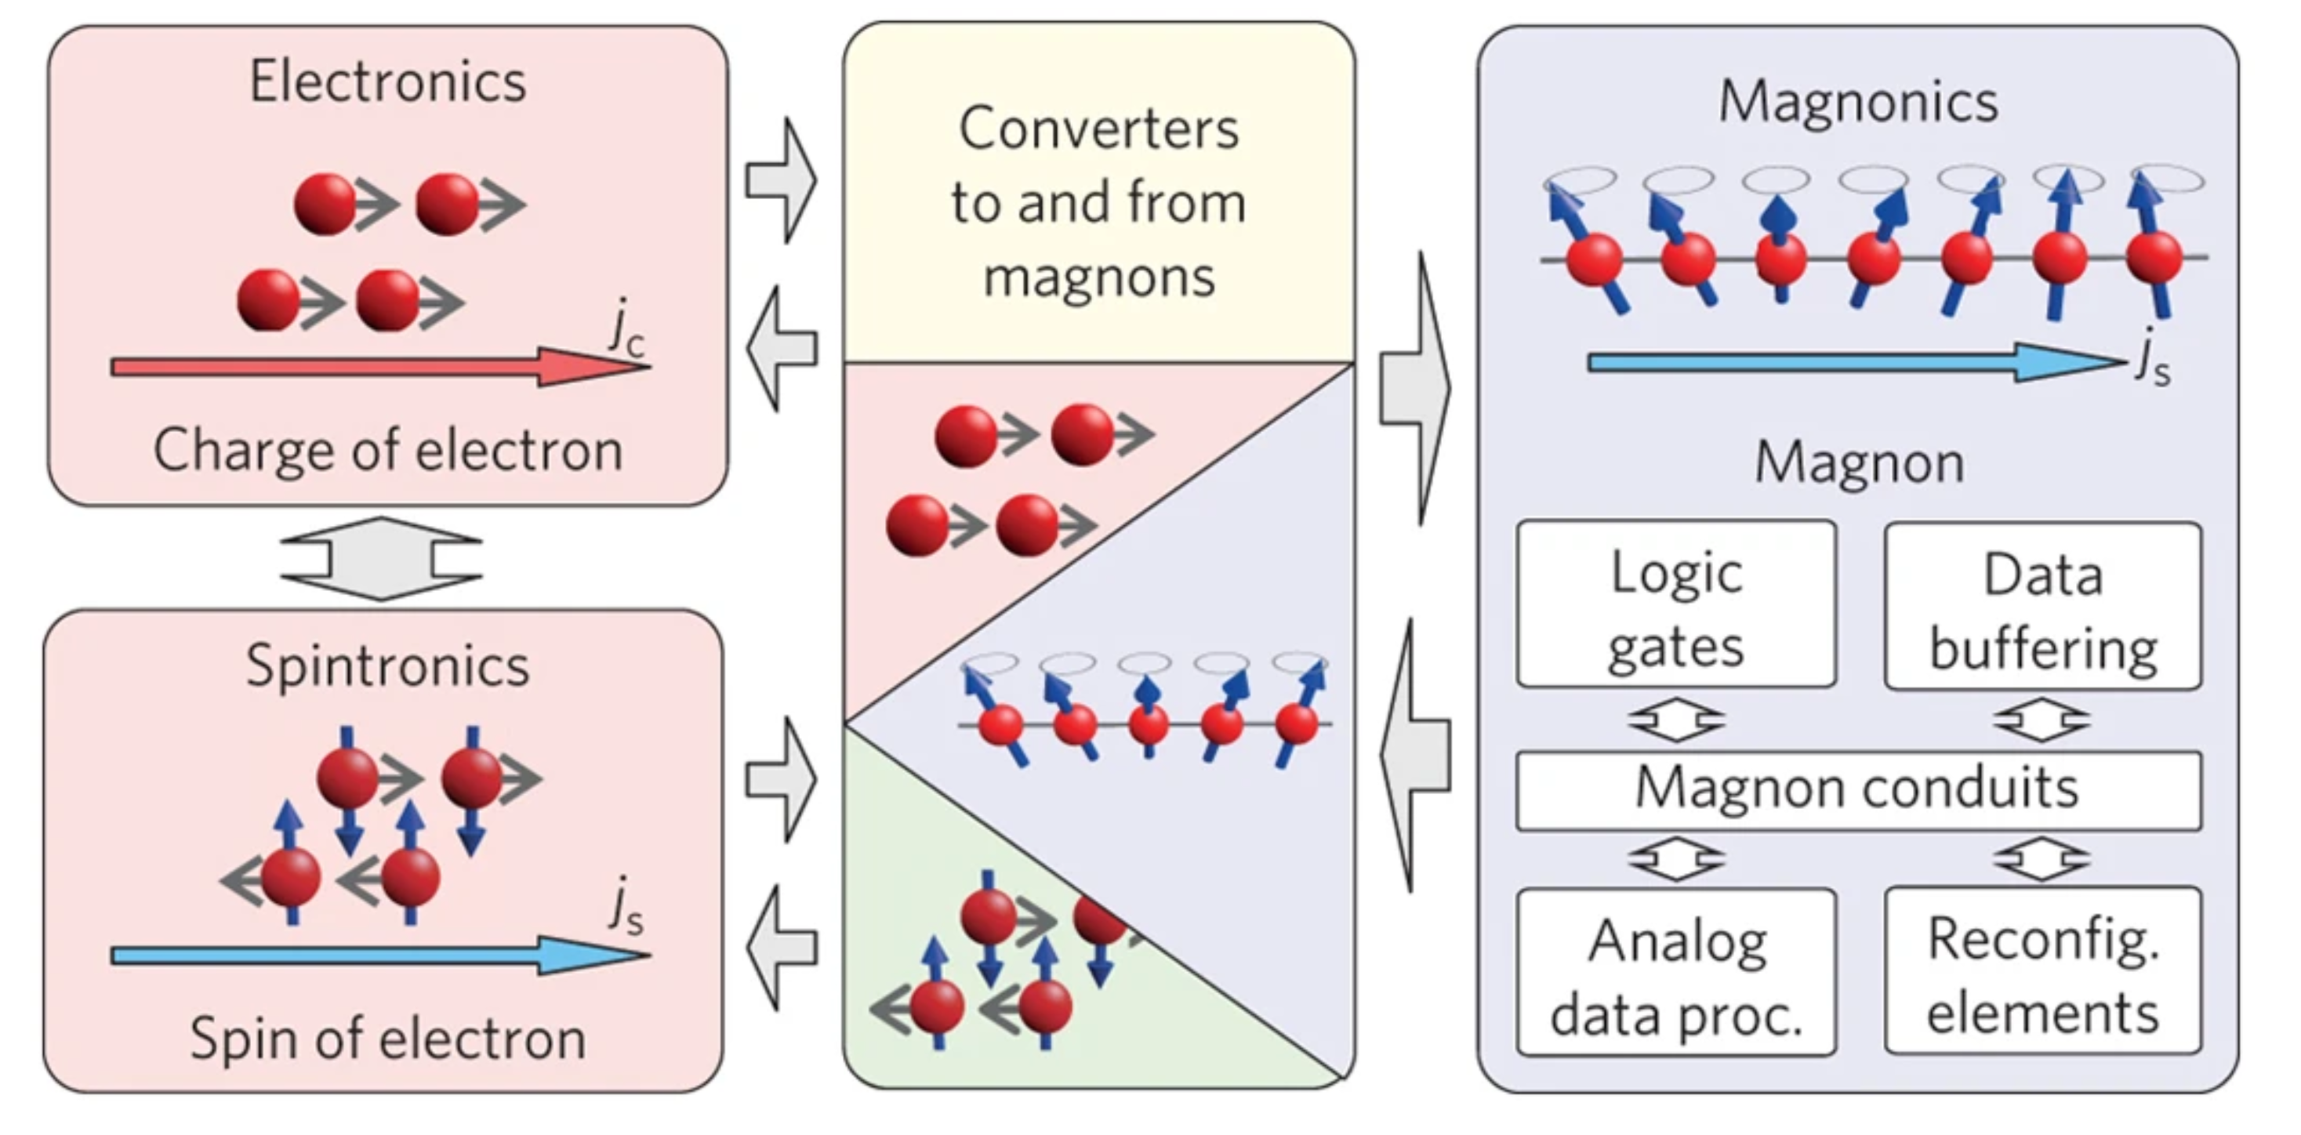
Figure 1. The concept of magnon spintronics. Adapted from [1]

The usefulness of magnons depends on how they propagate and dampen. If the propagation doesn’t have enough range, then a device cannot transmit the information far enough to be useful. If the damping is too strong, then the amplitude of the signal will decrease rapidly and lose coherence, which will cause the advantages of wave-based processing to disappear [2],[3].
Basic Theory of Spin Waves and Magnons
The starting point for magnon propagation is the magnetic order in a ferromagnet. The exchange interactions favor parallel alignment of neighboring spins, creating a ground state in which the magnetization points in a preferred direction [3]. If one spin is tilted away from equilibrium, the exchange field from its neighbors exerts a torque on it. Because those neighbors are also coupled to others, the disturbance spreads through the crystal as a collective oscillation rather than as an isolated local event. This spatially and temporally varying precession is the classical picture of a spin wave [3], [5].
The Landau–Lifshitz–Gilbert equation is often used to describe how magnetization changes over time [2], [3]. The equation has a precessional term, which makes the magnetization rotate around the effective magnetic field, and a damping term, which slowly brings the magnetization back to the direction of the effective field. The effective field can have many parts, such as an external applied field, an exchange field, a demagnetizing field, an anisotropy field, and sometimes even more interaction terms, depending on how the material is structured. The LLG framework is the best way to talk about propagation and damping analytically because they both come from the same dynamic equation [2], [3].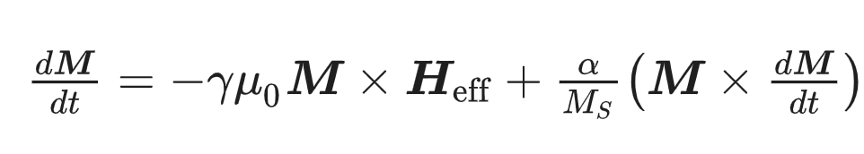
Figure 2. Landau-Lifshitz-Gilbert equation. Adapted from [3]
One of the most important outcomes of the LLG description is the spin-wave dispersion relation, which connects angular frequency to wavevector. The exact form of dispersion depends strongly on geometry and on the relative importance of exchange and dipolar interactions. At short wavelengths, exchange interactions dominate and the dispersion rises strongly with wavevector. At longer wavelengths, especially in thin films and patterned structures, dipolar interactions become important and can produce more complicated mode structures. Lenk et al. emphasize that understanding the dispersion relation is not a secondary theoretical detail; it is essential because it controls phase velocity, group velocity, propagation direction, wavelength selection, and the spectral windows in which particular devices can operate [3].

Propagation modes in Ferromagnetic Films and Waveguides
A major contribution of the early modern magnonics literature was the classification of practical spin-wave modes in ferromagnetic films. In a bulk or idealized medium, one can imagine relatively simple propagating waves, but in real thin films the situation is richer because surfaces and finite thickness matter. Lenk et al. discuss several important classes of modes, including backward-volume modes and surface modes of the Damon–Eshbach type, each of which arises from a particular relationship between magnetization direction, propagation direction, and internal field distribution [3].
Propagation also depends on the bias in the field and how close the operating frequency is to the cutoff conditions. At the bottom of a mode band, group velocity can get small. This can make the local density of states higher, but it can also make long-range transport less efficient. On the other hand, frequencies that are in a range with a good slope in the dispersion curve can help transport happen faster. [2], [3].
Damping Intrinsic and Extrinsic Mechanisms
Damping is the process by which the energy stored in a precessing magnetic system is irreversibly transferred to other degrees of freedom, causing the amplitude of magnetization oscillations to decrease with time and distance [2]. In the LLG equation, damping is most commonly represented through the Gilbert term and the dimensionless damping parameter alpha. If alpha is small, the magnetization precesses for many cycles before relaxing. If alpha is large, the motion decays more rapidly [2]. For propagating spin waves, this temporal damping becomes spatial attenuation because a wave packet moving through the medium loses amplitude as it travels [2].
In an idealized interpretation, intrinsic Gilbert damping reflects microscopic mechanisms that couple the spin system to the lattice and electronic environment. Energy leaves the collective spin precession and ultimately appears as thermal excitations or other dissipative channels. Even when a material is structurally perfect, intrinsic damping places a floor on how low the total loss can be. This is why low-alpha materials are so prized in magnonics: their intrinsic properties make them fundamentally better candidates for long-distance propagation [1], [2], [4].
However, measured damping in a real device is rarely purely intrinsic. Extrinsic contributions can be equally important or even dominant. Structural defects, grain boundaries, thickness nonuniformity, rough edges, impurities, and surface disorder can all scatter spin waves [5]. In patterned devices, lithography-induced damage and imperfect edges introduce additional inhomogeneities. These do not simply reduce amplitude in a uniform way; they can also redistribute energy between modes, broaden spectral features, and produce dephasing that degrades signal integrity. Kruglyak et al. describe such effects as one reason why practical magnonic devices must be evaluated not only by material name, but by fabrication quality and geometry [5].
Key Experimental Breakthroughs
Modern magnonics is not built on theory alone. Several experiments changed the way the field is understood and justified. One of the most important was the work of Kajiwara et al., which showed that electrical signals could be transmitted by spin-wave interconversion in a magnetic insulator [4]. In simple terms, this result showed that a signal could be launched into a magnetic medium, propagate in the form of magnons, and then be converted back into an electrical response. That closed the loop between magnetic-wave physics and device relevance.
Another major development came from work on dynamic control and amplification, reviewed extensively by Brächer et al. [2]. Magnon propagation by itself is not enough for large-scale information processing. Any useful wave-based technology must address how a signal is generated, maintained, manipulated, and possibly restored after attenuation. Parallel pumping and related amplification concepts address this need by injecting energy into the magnon system in a selective way.
Magnonic Devices and Applications
The technological appeal of magnons comes from the possibility of building devices that process information using wave phenomena. Chumak et al. present magnon spintronics as a field capable of supporting logic, transport, and signal-processing functions in ways that differ substantially from standard charge-current electronics [1]. Rather than encoding information only as high or low voltage, a magnonic device can use amplitude, phase, frequency, and interference. That expanded design space is one of the main reasons the field remains attractive despite the difficulties posed by damping and integration.
The spin-wave logic element is one type of device that has been suggested.[3] In this kind of device, signals can either add up or cancel each other out, depending on how they are phased. If phase is used as an input variable, the amplitude at a detector can be used to figure out logic states. This makes it possible for ideas in which logical operations are done by propagation and interference instead of by switching transistors on and off many times. It's not just the novelty that makes it appealing. Wave-based logic might be able to make some functions work in a small space, especially when it's easy to combine several inputs in one interference region [1], [3].
Major Challenges Preventing Wider Adoption
Despite steady progress, several challenges continue to limit the practical adoption of magnonic technologies. The first and most obvious is damping itself. Even in a good material, the wave amplitude decreases as energy is transferred out of the coherent spin-wave channel. For small laboratory devices this may be manageable, but in larger or more complex circuits repeated attenuation becomes a major obstacle. A platform based on wave interference requires not just detectable propagation but sufficient amplitude and phase fidelity at the point of computation or detection. Once damping becomes too strong, the very properties that make magnons attractive—coherence and interference—are lost [1], [2].
A second challenge is signal transduction. Most modern systems still begin and end in the electronic domain. That means a practical magnonic platform needs efficient ways to convert electrical inputs into spin-wave excitations and then reconvert them into measurable outputs. Kajiwara et al. showed that such interconversion is possible [4], but efficient, compact, scalable transducers remain an engineering challenge. Any losses at the interfaces reduce the system-level benefit of using magnons in the first place.
A third challenge is mode complexity. In a real waveguide or patterned structure, multiple modes may be present. A source may unintentionally excite several of them, which then propagate at different velocities or interfere with one another. From a physics perspective this richness is interesting, but from a circuit perspective it can complicate operation. Devices often need clean mode selectivity to behave predictably. Achieving that selectivity requires careful design of geometry, excitation conditions, and operating frequency [3].
Where the Field is Going
The future direction of magnonics can be understood as a convergence of better materials, better structures, and better control. On the materials side, researchers continue to seek films with lower damping, cleaner interfaces, and stronger compatibility with microfabrication. Even if YIG remains the benchmark for low-loss transport, practical systems may require a broader set of materials that trade a modest increase in damping for easier integration with standard processing technologies [1], [4], [5].
On the structure side, the trend is toward increasingly sophisticated patterning. Rather than relying on simple straight strips, future devices may use networks of guides, resonant cavities, periodic regions, and local field-engineering features such as antidots. These structures can create bandgaps, steer waves, control phase accumulation, or launch propagating modes from compact regions. The antidot work already shows that local demagnetizing-field engineering is a powerful concept [6]. It is reasonable to expect that future device design will rely even more heavily on such geometric approaches.
Brächer et al. show that amplification and pumping concepts can be brought into magnon spintronics rather than treating damping as an unavoidable one-way loss [2]. If magnonic systems are to become functional circuits, they will likely require local gain, selective attenuation, and dynamic tuning. This would make them more analogous to practical photonic and microwave systems, where passive and active elements are combined to achieve useful performance.
Conclusion
The fundamental principles of magnon spintronics are the propagation and damping of magnons in ferromagnetic materials. Spin waves are a promising way to move information because they let signals move without the usual flow of charge. They also let waves do things like interference, phase control, and frequency selectivity. But these benefits are limited by damping, which makes the signal's amplitude and coherence weaker as magnons move through a material.
The Landau–Lifshitz–Gilbert equation describes how magnetization changes over time, and the dispersion relations for different spin-wave modes show how magnons behave. Both intrinsic and extrinsic damping mechanisms are very important for determining how far a signal can travel and how well a device works as a whole. In real systems, the quality of the materials and the design of the geometry have a big effect. Experimental demonstrations, especially in low-damping materials like yttrium iron garnet, have shown that it is possible to transport magnons over long distances [4].
Even with these improvements, there are still big problems to solve. Damping, signal transduction between electronic and magnonic systems, and mode complexity continue to limit scalability and integration into practical technologies. The future of magnonics will depend on how well we can keep making materials better, how well we can make nanostructures, and how well we can control spin-wave dynamics.
Overall, magnonics is a promising but still growing way to process information. It probably won't completely replace traditional electronics, but it does have some unique benefits for low-power and wave-based uses. The degree to which these systems can be incorporated into next-generation computing technologies will depend on ongoing advancements in the comprehension and regulation of magnon propagation and damping.
Citations
[1] A. V. Chumak, V. I. Vasyuchka, A. A. Serga, and B. Hillebrands, “Magnon spintronics,” Nature Phys, vol. 11, no. 6, pp. 453–461, Jun. 2015, doi: 10.1038/nphys3347.
[2] T. Brächer, P. Pirro, and B. Hillebrands, “Parallel pumping for magnon spintronics: Amplification and manipulation of magnon spin currents on the micron-scale,” Physics Reports, vol. 699, pp. 1–34, Jun. 2017, doi: 10.1016/j.physrep.2017.07.003.
[3] B. Lenk, H. Ulrichs, F. Garbs, and M. Münzenberg, “The building blocks of magnonics,” Physics Reports, vol. 507, no. 4–5, pp. 107–136, Oct. 2011, doi: 10.1016/j.physrep.2011.06.003.
[4] Y. Kajiwara et al., “Transmission of electrical signals by spin-wave interconversion in a magnetic insulator,” Nature, vol. 464, no. 7286, pp. 262–266, Mar. 2010, doi: 10.1038/nature08876.
[5] V. V. Kruglyak, S. O. Demokritov, and D. Grundler, “Magnonics,” J. Phys. D: Appl. Phys., vol. 43, no. 26, p. 264001, Jul. 2010, doi: 10.1088/0022-3727/43/26/264001.
[6] C. S. Davies, A. V. Sadovnikov, S. V. Grishin, Yu. P. Sharaevskii, S. A. Nikitov, and V. V. Kruglyak, “Generation of propagating spin waves from regions of increased dynamic demagnetising field near magnetic antidots,” Applied Physics Letters, vol. 107, no. 16, p. 162401, Oct. 2015, doi: 10.1063/1.4933263.

ChatGPT (OpenAI) was used to assist with drafting and structuring. All content was reviewed and edited by myself.

